Connecticut River Watershed Ecosystem Goal
- The Connecticut River watershed sustains a diverse suite of intact, connected, and resilient ecosystems that provide important ecological functions and services that benefit society, such as clean water, flood protection, and lands for farming, forestry, and recreation.

Potential Objectives
“Fundamental objectives” – objectives that we are trying to achieve (collectively contribute to the overall ecosystem goal):

- Ensure the existence of a spectrum of ecosystems that encompasses a full range of biodiversity (genetic, species, and natural community) and supports a multitude of ecosystem functions and services.
- Ensure that ecosystems are of a size and condition, and situated in a landscape context, that will preserve their long-term resilience.
- Maintain ecosystems in a well-distributed, interconnected network that 1) facilitates short-term movements and long-term range shifts of a diversity of both aquatic and terrestrial species and 2) allows ecological processes such as aquatic flows to operate at large scales.

“Means objectives” – means by which the conservation design helps achieve these fundamental objectives:

- The conservation design will depict areas of the highest priority (“core areas”) that can be considered the most important locations for achieving the fundamental objectives (best or most urgent places to start). However, by themselves they are unlikely to be sufficient to fully achieve the objectives.
- The conservation design will also depict additional tiers of priority, including priority connections areas or corridors, that collectively contribute to the fundamental objectives.
- The conservation design will include priorities for management and restoration that over time can enhance ecological value and improve natural processes that link ecosystems.

Trade-offs in designating core areas to achieve the objectives. The header rows in the tables represent two extremes in alternatives to approaches in the design process, with the arrows indicating a range of intermediate possibilities between the extremes.

Less area in cores More area in cores
Core areas are more strategic and their protection is potentially more feasible, ensuring the most important areas are conserved | Core areas encompass a greater degree of biodiversity and natural processes, but also comprise a greater mix of higher and lower priorities

More, smaller core areas Fewer, larger core areas

Core areas are only the “best” Core areas are “grown out” from
examples of ecosystems (“slice” a “seed” of a small amount of
of the highest values) high value areas to create more
consolidated units
Diversity | Best examples of ecosystem diversity are retained | Some loss of high value ecosystems, but functions and services may be more intact
Condition | On average, core areas are smaller and less intact | Core areas are larger and more intact; complexes of ecosystems are retained together
Connectedness | More “stepping stones” for greater long-distance connectivity | Greater connectedness within core areas

To select core areas, ecosystem results are scaled by:

Subwatershed Full Connecticut River
(e.g., HUC 8) Watershed
Diversity | By ensuring more uniform representation, may enhance overall genetic and species diversity | Likely that best examples of diversity represented, with more intact functions and processes
Condition | On average, core areas may be in lesser condition and less resilient | Larger, more intact areas likely to be in better condition and more resilient
Connectedness | Greater network-wide connectivity because core areas are more evenly distributed | Greater short-distance connectivity where core areas are clustered but less connectivity where core areas are sparser

Ex. 1. Less areas vs. more areas in cores

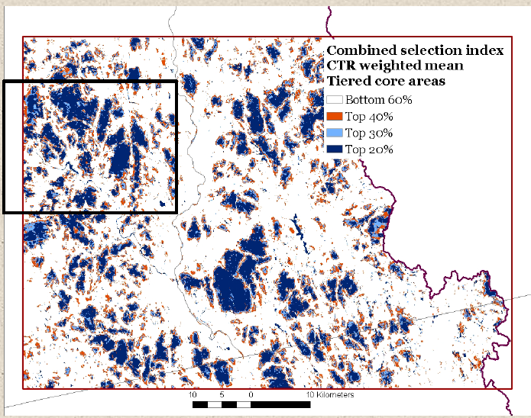

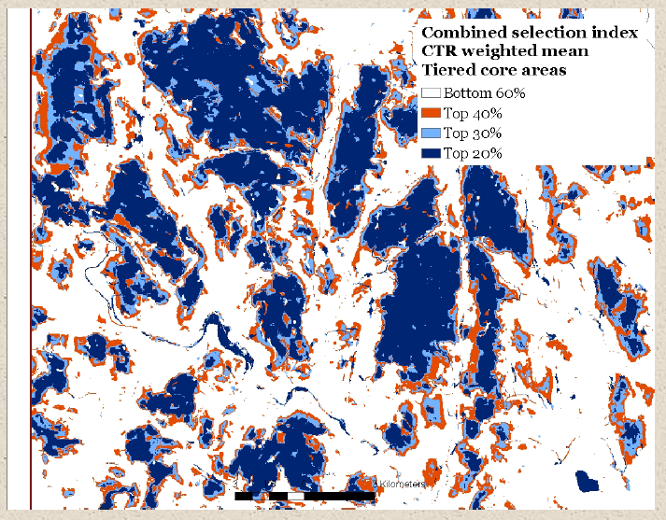

Ex. 2. More, smaller core areas (straight “slice”) vs. fewer, larger core areas
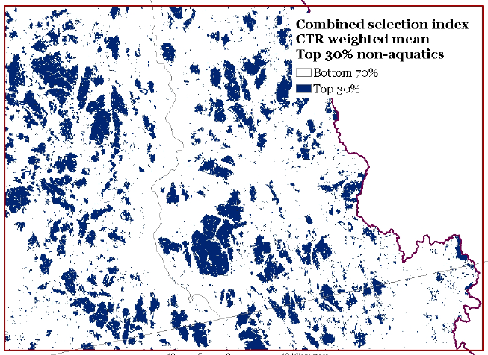
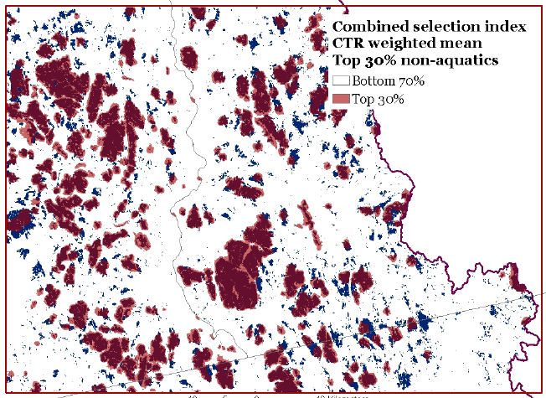
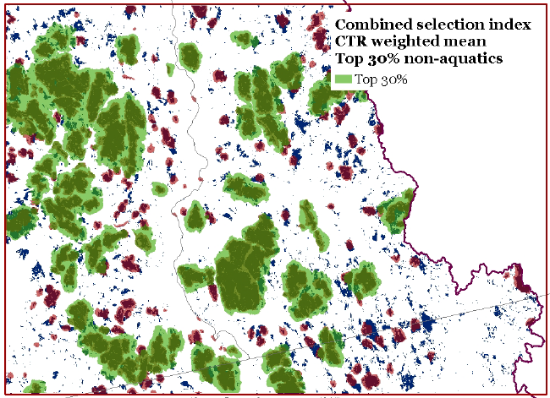

Ex. 3. Scale ecosystem results by HUC8 vs. a single scaling for the whole watershed
